Programming for Computer games

2D:

Construct 3

Phaser 3

Game Maker Studio 2

Godot

3D:

Unity

OpenGL

Ogre

Panda3d

Features about each game engine

Construct 3

1. It’s an easy to use Game engine which doesn’t require actual programming.
2. Includes JavaScript coding
3. Can create games for mobiles.
4. Is backwards compatible with Construct 2
5. Has z elevation to make your game look 3d.

Phaser 3:

1. Can be rendered in WebGL or a canvas depending if the browser supports WebGL
2. Games can be developed with 1 of the 2 supported scripts
3. The said scripts are JavaScript and TypeScript
4. Is a full body Physics system, has Arcade Physics system, Ninja Physics system and P2.JS
5. Animation is supported in Phraser 3 by loading a spritesheet, texture atlas and creating an animation sequence

Game Maker Studio 2:

1. Can export games in various different systems such as Windows Desktop, Mac OS X, Ubuntu, Android, IOS, tvOS, FireTv, Android TV, Microsoft UWP, HTML 5, PS4 and XBOX one
2. Has Github save and backup support
3. Has support for adverts without charging extra for the service
4. The game engine itself deals with the network and server management.
5. Has a brush based editing

Godot:

1. Has a built in code editor
2. Supports various different languages
3. Multi-platform editor
4. Export games on various different systems with easily
5. Has a built in debugger

3D

Unity:

1. Visual Studio C# integration
2. Easy to sell games thanks to Unity Asset store
3. Free license for personal use or companies that generate less than 100000 annually
4. Has various supported platforms to export your game in.
5. Supports full screen rendering

OpemGL:

1. Increase readback speed with pixel buffer object
2. Texture Compression
3. Increase texture cache with Mip-Mapping
4. Has lens Flares
5. Cross Language and cross platform

Ogre:

1. Highly flexible scene management
2. Flexible plugin architecture for engine to be extended without recompilation
3. Multiple shadow rendering techniques
4. Generic animation tracks accept pluggable object adapters
5. Easy to use projective texturing support

Panda3d:

1. Has immense platform portability
2. Includes pstats
3. No complicated initialization code
4. Able to make new graphics techniques
5. Supports many third party libraries

Programming languages used in game engines

1. C++
   1. Object oriented language
   2. Many already made libraries available
2. Java
   1. Loads of Game Development tools
   2. Multi-threaded programming language
3. HTML5
   1. Easy to maintain and update
   2. No need for additional plug-ins
4. JavaScript
   1. Interpreter Based Language
   2. Object Based Language
5. SQL
   1. To create User profiles
   2. Able to handle large data
6. Python
   1. Rapid Game prototyping
   2. Object oriented Language
7. Rust
   1. Zero Cost Abstraction
   2. Move semanatics.

Compression in multimedia objects:

Data compression is the process used to reduce the amount of that that is needed to store a multimedia object. The advantages and importance of compression is using less expensive resources such as disk space, makes it easier for the computer to read and write, this means when loading the compressed files it will take less time and give less of a strain on the computer to load the said file. Since a compressed file uses less disks place means that file transfer is much easier and faster.

Image compression

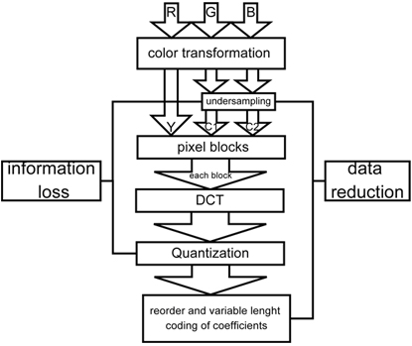

**1.Color Conversion and Subsampling:**

**Color information is sub-sampled without significant loss to quality**

**2.** Each bock is transformed using the discrete Cosines Transformation (DCT)

3. These are quantized

4.Reducing redundancies in the code, for examples if there are ten 0’s its 10x0 instead.